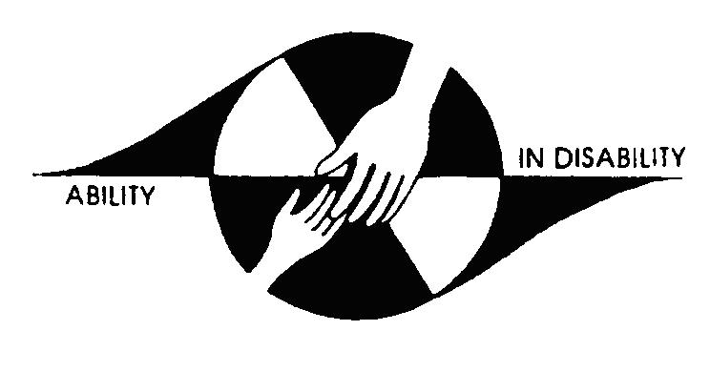
Beenleigh State Special School
Strategic Plan 2020 – 2023

‘Building a Culture that Promotes Learning - Student Cognitive, Affective and Behavioural Engagement’
School Profile
Beenleigh Special School is located in the northern end of the South East Region. Students are drawn from a wide geographic area that includes suburbs within the Gold Coast City, Logan City and Beaudesert Shire councils. The students attending the school are verified with an intellectual disability and may have an additional diagnosis of Autism, physical impairment, hearing impairment or visual impairment. The students range in age from 4 to 17 years old. Students in the school are drawn from a diverse range of economic and social backgrounds.
Beenleigh Special School is divided into four sectors: Early Years (P-2), Upper Primary (Year 3 - 6), Junior Secondary (Year 7 - 10) and Senior Secondary (Year 11 - 12). The Australian Curriculum is implemented across the school with a focus on high quality and innovative units of work in English, Mathematics, Science, Health and Physical Education, Humanities and Social Science, LOTE, Technologies and The Arts. To cater for each individual student's needs, each student in Years P - 10 has an Individual Curriculum Plan which is reviewed every six months. Senior Secondary students also have a Planning Alternate Tomorrows with Hope (PATH) and Senior Education and Transition Plan (SETP) that identifies goals for their senior schooling pathway which is reviewed every six months. At the completion of their schooling, students receive a Queensland Certificate of Individual Achievement from the Queensland Curriculum and Assessment Authority.
Vision
Beenleigh Special School provides an inclusive and specialised learning environment focused on high expectations and supporting students to develop independence and the confidence to be a listener, word user, safe and fair across a range of environments.
Values
- We value diversity and cater for individual strengths and qualities of the whole school community.
- We value the physical, social and emotional wellbeing and development of each student to be a listener, word user, safe and fair.
- We value collaboration and teamwork to deliver flexible options and innovative learning experiences to achieve high levels of success.
- We value a safe, nurturing, accepting and supportive learning environment to achieve high student outcomes.
- We value open communication with all members of the school community built on trust, honesty and integrity.

Improvement Priorities
Priority: Systematic Curriculum Delivery
Success Indicators:
- Increased confidence of P-10 teachers to appropriately plan, teach and report on student learning, embedding general capabilities and cross curriculum priorities.
- Auslan taught as a Language other than English (LOTE) to meet Australian Curriculum requirements. Auslan Language Model (ALM) supports identified students. Increased confident of teachers to integrate Auslan into curriculum delivery.
- Increased teacher confidence in ability to deliver Australian Curriculum in creative, age appropriate and inclusive ways.
- Literacy continuum developed and utilised to inform and identify student progress.
- All Australian Curriculum subjects, including Technologies and LOTE implemented across P-10 classes by the end of 2020.
- Documented differentiated teaching strategies and data tracking is used to inform recorded teaching adjustments.
- Senior School policies and procedures updated and aligned with school’s Curriculum Assessment and Reporting Framework (CARF).
- Increased range and number of partnerships between schools, private providers, local employers and disability services to cater for individual student needs and post-school pathways.
- Increased confidence of Senior School teachers to appropriately plan, teach, assess and report on student learning.
Strategies
 | 2020 | 2021 | 2022 | 2023
Refine the curriculum planning process to explicitly incorporate engagement with the learning area content, general capabilities and cross-curriculum priorities to ensure consistent and deep understandings of all elements of the Australian Curriculum.
Develop an understanding of Auslan as LOTE and embed delivery across Upper Primary and Junior Secondary classrooms.
Collaboratively develop staff understanding and capability to plan and implement Australian Curriculum in creative ways to consistently challenge and engage all learners.
Develop a Literacy continuum for students working from Literacy 1b – Year 4 that will enable teachers to develop individual learning goals and track progress.
Implement a planned approach to full implementation of the Australian Curriculum including Languages and Technologies.
Formalise processes to quality assure and review differentiation practice across the school.
Utilise an Inquiry Cycle to review the systems, operations and partnerships to support students to transition to post-school options.
Update Senior School documentation and whole school Curriculum, Reporting and Assessment Framework including transition to post-school options, curriculum development, program delivery and sustainable resourcing.

Priority: An Expert Teaching Team
Success Indicators:
- Evidence-based feedback, coaching and mentoring processes, including Beginning Teacher Mentor program, documented and enacted.
- Formal process for peer observation, learning walks and Watching Others Work documented and enacted.
- Whole School Professional Learning Plan is reflective of individual and school priorities and offers opportunities to build leadership capability.
- Differentiated professional development opportunities for all staff aligned to Developing Performance Plan goals and school priorities including PBL, Auslan, data literacy and Senior School.
- Increased staff confidence in managing student behaviour.
- Increased staff confidence in using Auslan to communicate with all members of the school community.
- Diagnostic data collected in accordance with Curriculum, Assessment and Reporting Framework and recorded in OneSchool.
- Increased teacher confidence in data literacy including collecting and analysing student data sets.
Strategies
 | 2020 | 2021 | 2022 | 2023
Extend the current feedback, coaching and mentoring processes aligned to school improvement priorities including Beginning Teachers, Literacy, Numeracy and pedagogical practices.
Develop and enact formal peer observation, learning walks and Watching Others Work processes for teachers aligned to school improvement priorities and individual developing performance goals.
Develop systematic processes strategically aligned to the explicit improvement agenda to build leadership opportunities and capabilities for teaching and leadership staff including Experienced Senior Teacher, Highly Accomplished and Lead Teacher accreditation.
Provide further opportunities for teacher aides to develop deeper knowledge in relation to school priorities through differentiated professional development.
Further develop and upskill staff in PBL systems and processes, data analysis and discussion to ensure consistent and effective practices are embedded across the school.
Further develop and upskill staff in Auslan, ensuring cultural integrity through liaison with the deaf community.
Build the capacity of Senior School staff to deliver student programs through targeted professional development linked to Developing Performance Plans – Certificate IV in Workplace Assessment and Training, QCIA and PATH.
Build teacher capacity in analysing and using data to inform curriculum planning and reflection on practice.
Engage in targeted professional development in order to develop data literacy skills for all teachers and school leaders.

Priority: A Culture that Promotes Learning

Success Indicators:

- Positive Behaviour for Learning (PBL) is rejuvenated and effectively implemented across the whole school: Student Code of Conduct completed and shared with school community, increased staff confidence in managing student behaviour.
- Berry Street Education model implemented as a whole school approach to trauma-informed practice.
- Parent and Community Engagement Framework updated and reflective of school priorities.
- Welcoming and culturally safe school environment created through support of Indigenous Champions.
- Case management process developed and implemented to identify, monitor and manage student achievement, wellbeing and attendance.
- Whole school process for identification of individual learning intentions is developed and implemented to target and monitor student outcomes.
- Diagnostic data used to determine student learning expectations and goals within ICPs to analyse and track student progress and celebrate achievement.
- Roles and responsibilities of all staff clearly defined and communicated to whole school community.
- Alternative and Augmentative Communication (AAC) whole school focus on communication tools, environments and partners embedded into school practice.
Strategies
 | 2020 | 2021 | 2022 | 2023
Review the structures and processes supporting implementation of PBL to ensure consistency across the school.
Build capacity of whole staff on fundamentals of Berry Street Education Model to assist in adopting whole school approach to trauma informed practice.
Review and update Parent and Community Engagement Framework to reflect school priorities including Senior School partnerships, student wellbeing, Indigenous perspectives and increased opportunities for parent support and engagement
Identify Indigenous Champions and complete South East Region Cultural Audit Checklist to identify areas of improvement and develop an action plan to support move towards a welcoming and culturally safe school environment.
Develop and implement a whole-school strategy and case management process for identifying explicit targets, effectively monitoring and managing student learning outcomes, achievements, attendance and wellbeing.
Collaboratively develop school wide visible learning processes that support staff and students to track progress, monitor learning and assess achievement.
Use a systems leadership paradigm to review the roles and responsibilities of all staff to better align and support school initiatives.
Extend whole school focus on AAC; focusing on improving communication partner skills, individualising tools and creating communication accessible environments.

Additional School processes and programs to support school improvement: Education Program Officer, Balanced Literacy, Alternative and Augmentative Communication, Positive Behaviour for Learning, Auslan Language Model, Indigenous Champions, Berry Street Education Model

Endorsement
This plan was developed in consultation with the school community and meets identified needs and systemic requirements.
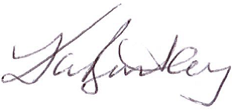

_______________________ _______________________ _______________________
Nicole Finch - Principal Sharon Stephenson - P&C President Kate Bentley – Assistant Regional Director

